**Design Document – GAIA**

**Game Demographic**

* Children & Teens
* Female and Male (Mostly Female)
* Mobile and Tablet

**Game Concept**

Players raise small slime creatures on a floating island to become the best they can be, by feeding them various kinds of fruit. This fruit will increase the stats of creatures and by breeding creatures together, and swapping other creatures for an abundance of fruit, players will ultimately produce a better creature. Ultimately, players will care for and selectively breed their creatures in order to have the best specimen which they will use to compete with other player’s creatures.

**Game Start**

[1] Players start on an island with 2 Eggs. These eggs can be any combination of the primary colours. Eggs will hatch between a set time (Variable Reward, between 5-15 seconds) and repeatedly tapping them will allow them to hatch faster.

[2] Creatures hatch and start roaming around. Occasionally, creatures will reward players with gifts containing seeds. Sometimes, meteors will fly overhead. If the Player taps that meteor, it transforms into a gift and falls to the island. It will contain either a Primary Coloured Egg or a seed.

[3] Players can plant up to 3 seeds on the island at once. Trees grow from between 30 seconds and a minute, and like the Eggs, rapidly tapping the trees increase their rate of growth. Trees produce fruit at a fixed rate. These fruit are used to regulate mood and to level up the creatures’ stats (Creatures have to be fed 2-3 fruits to do this).

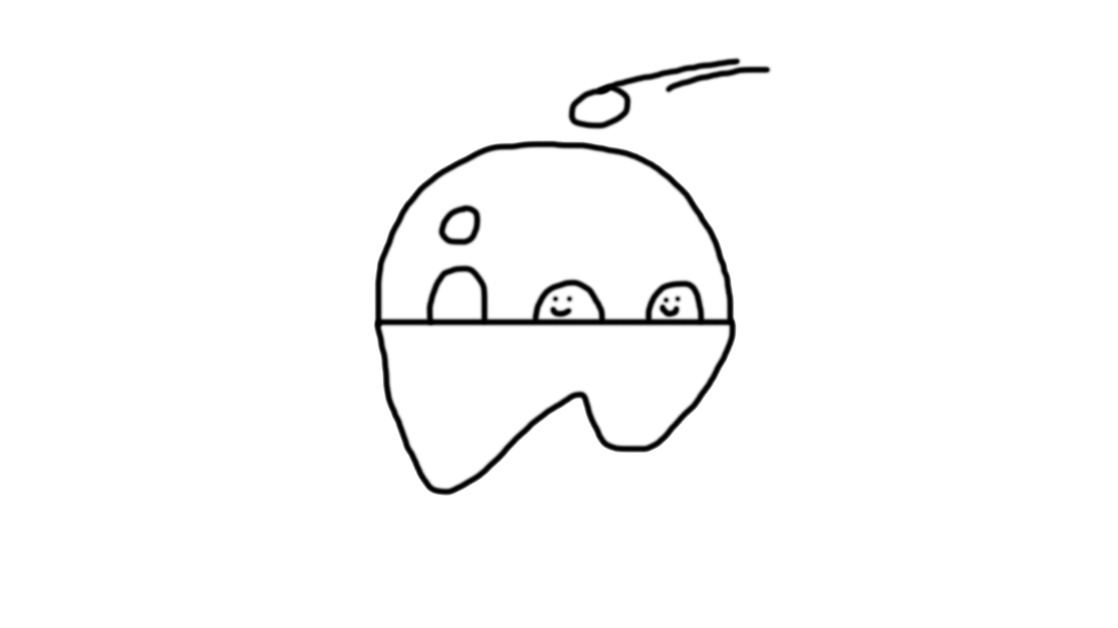

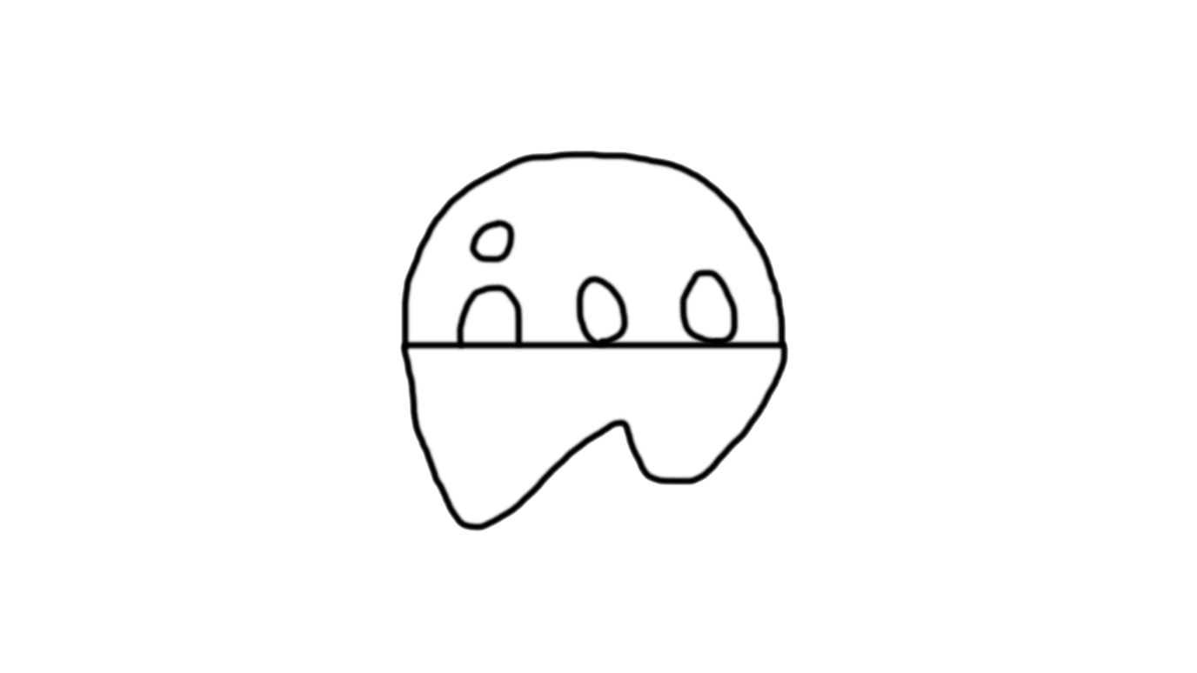[1]  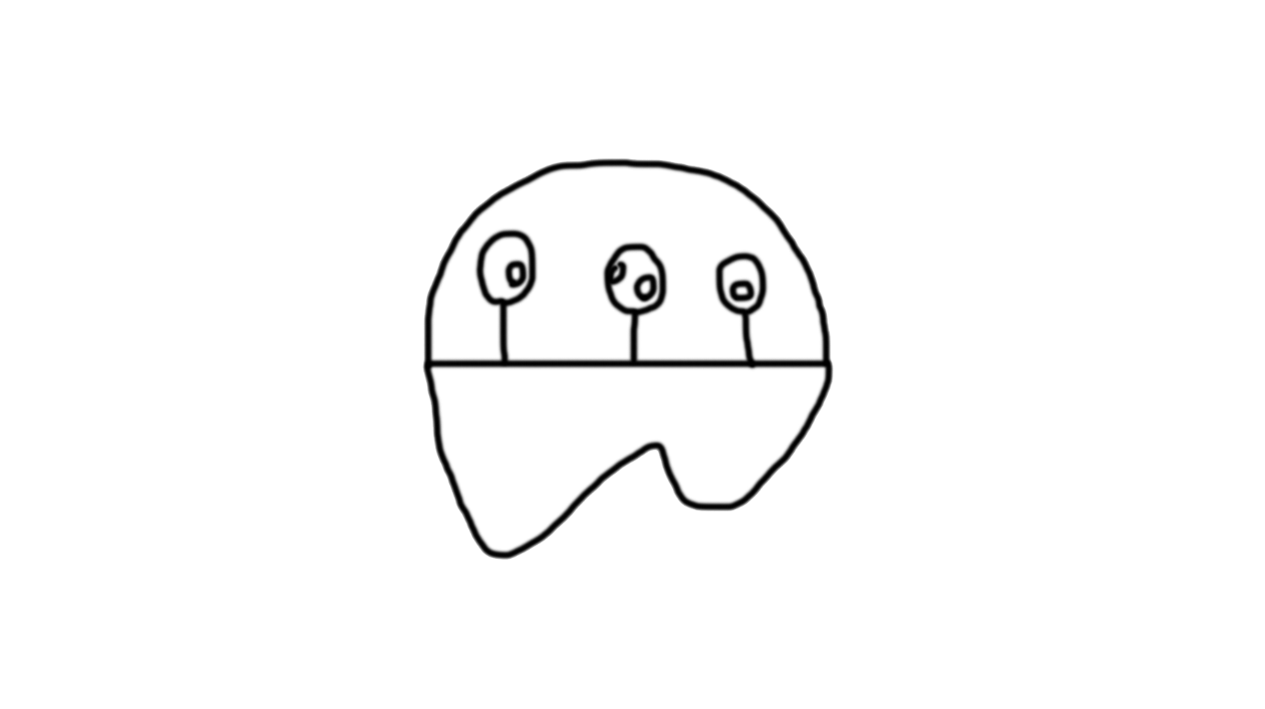[2]

[3]

**Feeding System**

Tap fruit on the Tree to Knock it to the ground. Once on the ground, players can tap on a creature to get its attention then tap on a fruit to guide the creature to it. The creature then eats the fruit. Depending on the fruit, creatures’ STATS will increase in level, NOT AFFINITY. Depending on the Creature’s preference, fruit may also increase its mood. To level up a STAT, you must feed your creature up to 3 of the relevant fruits.

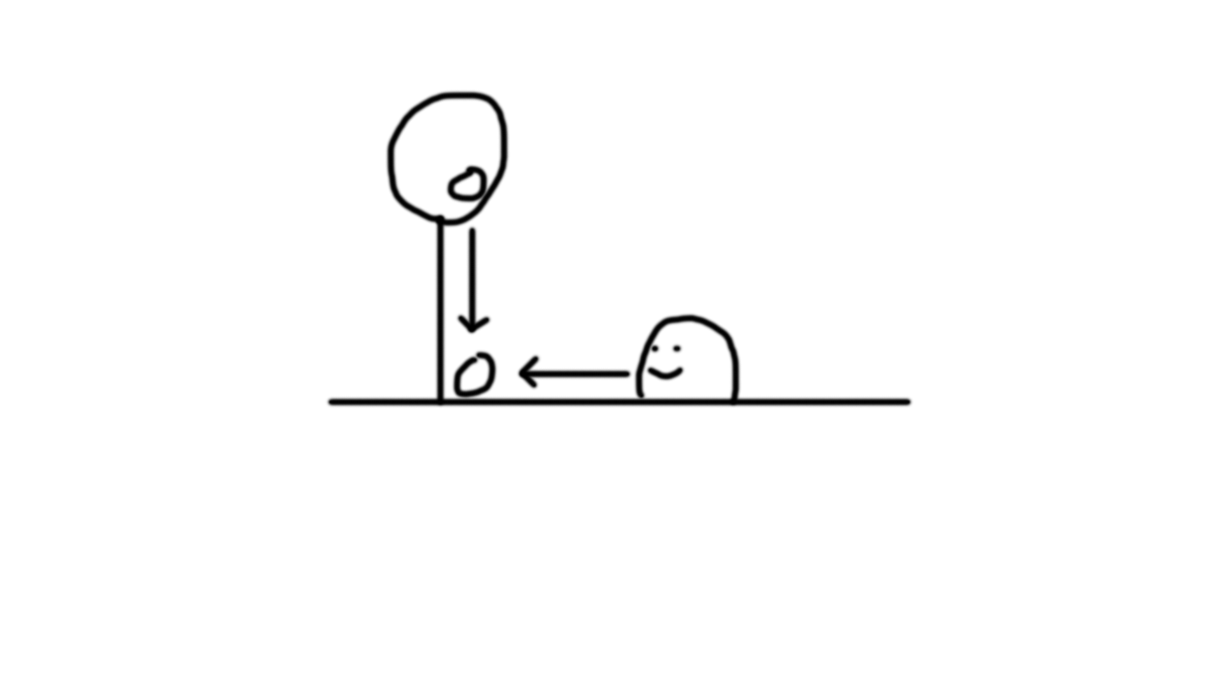

[3]

[2]

[1]

**Affinity System**

Depending on the Affinity of the STAT, it has a higher Maximum Potential.

|  |  |  |
| --- | --- | --- |
| **AFFINITY** | **LEVEL** | **ACTUAL VALUE** |
| A | 99 | 990 |
| B | 99 | 891 |
| C | 99 | 792 |
| D | 99 | 693 |
| E | 99 | 594 |
| F | 99 | 495 |

When a Level increases, a random number is picked between the Actual Value Boost Range of the Affinity and is applied to the Actual Value.

|  |  |
| --- | --- |
| **AFFINITY** | **ACTUAL VALUE BOOST RANGE** |
| A | 6-10 |
| B | 5-9 |
| C | 4-8 |
| D | 3-7 |
| E | 2-6 |
| F | 1-5 |

**Contest**

Players Network to compare creatures. The STAT is randomly selected. The player whose creature has the highest ACTUAL VALUE for that STAT wins. The Winner then receives a prize that is randomly selected e.g. 3 fruit/5 fruit/10 fruit.

**Breeding System**

Players can breed their creatures in order to create a creature that merges its parents’ STATS. Parent STATs that have been levelled up the most get an additional +1 when breeding. For example, ‘E + E = E’ unless one or both of the parents have levelled up that STAT the most, so it would then be ‘E + E = D’. If the STATs are the same and neither parent has levelled up that STAT the most, there is a 1/10 chance that the STAT will increase.

